TASK 7A

import 'package:flutter/material.dart';
import 'package:flutter/services.dart';

void main() => runApp(const MainApp());

class MainApp extends StatelessWidget {
const MainApp({super.key});

@override
Widget build(BuildContext context) {
return MaterialApp(
home: Scaffold(
appBar: AppBar(title: const Text('Form Application')),
body: Column(
children: <Widget>[
Image.asset('images/3d_avatar_21.png', width: 100, height: 100),
// Custom text fields for user input
const CustomTextField(label: 'First Name'),
const CustomTextField(label: 'Last Name'),
const CustomTextField(label: 'Email', suffixText: '@mlritm.ac.in'),
const CustomTextField(
prefixText: '+91 ',
label: 'Phone Number',
keyboardType: TextInputType.phone,
maxLength: 10,
),
const Divider(indent: 8, endIndent: 8), // Divider
const CustomTextField(label: 'Username'),
const CustomTextField(label: 'Password', obscureText: true),
const CustomTextField(label: 'Confirm Password', obscureText: true),
ElevatedButton(
onPressed: () {},
child: const Text('Register'),
),
],
),
),
);
}
}

// Custom text field widget
class CustomTextField extends StatelessWidget {
final String label;
final TextInputType? keyboardType;
final bool obscureText;
final String? prefixText, suffixText;
final int? maxLength;

const CustomTextField({
super.key,
required this.label,
this.keyboardType,
this.suffixText,
this.prefixText,
this.maxLength,
this.obscureText = false,
});

@override
Widget build(BuildContext context) {
return Padding(
padding: const EdgeInsets.symmetric(vertical: 8, horizontal: 16),
child: TextFormField(
keyboardType: keyboardType,
obscureText: obscureText,
inputFormatters: maxLength != null
? [LengthLimitingTextInputFormatter(maxLength)]
: null,
decoration: InputDecoration(
border: const OutlineInputBorder(),
labelText: label,
suffixText: suffixText,
prefixText: prefixText,
),
),
);
}
}
- Open the pubspec.yaml file in your Flutter project and add the following lines after flutter: to include the image asset in your project:
- flutter:
- # ...
- assets:
- images/3d_avatar_21.png <-- Add this line
Save the file.
- Run your Flutter project using the following command:
flutter run
Select the appropriate device to run the app.
- During the app execution, you can use the following commands:
  - Enter r to hot reload the app and see the changes you made to the code.
  - Enter q to quit the app.
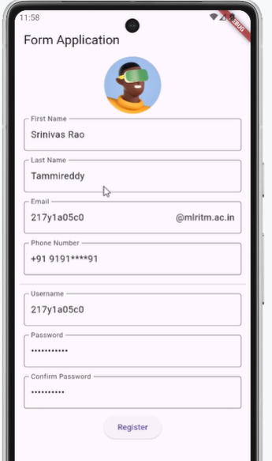

TASK 7B
import 'package:flutter/material.dart';

void main() => runApp(const MainApp());

class MainApp extends StatelessWidget {
const MainApp({super.key});

@override
Widget build(BuildContext context) {
return MaterialApp(
home: Scaffold(
appBar: AppBar(title: const Text('Form Validation')),
body: const SingleChildScrollView(
child: RegisterForm(),
),
),
);
}
}

class RegisterForm extends StatefulWidget {
const RegisterForm({super.key});

@override
State<RegisterForm> createState() => _RegisterFormState();
}

class _RegisterFormState extends State<RegisterForm> {
final _formKey = GlobalKey<FormState>();
final _nameController = TextEditingController(),
_emailController = TextEditingController();

@override
Widget build(BuildContext context) {
return Form(
key: _formKey,
child: Column(
children: <Widget>[
Padding(
padding: const EdgeInsets.symmetric(vertical: 8, horizontal: 16),
child: TextFormField(
controller: _nameController,
decoration: const InputDecoration(labelText: 'Name'),
validator: (value) {
if (value == null || value.isEmpty) {
return 'Please enter your name';
}
if (!RegExp(r'^[a-zA-Z][a-zA-Z\s]*$').hasMatch(value)) {
return 'Name can only contain letters and spaces in between';
}
return null;
},
),
),
Padding(
padding: const EdgeInsets.symmetric(vertical: 8, horizontal: 16),
child: TextFormField(
controller: _emailController,
decoration: const InputDecoration(labelText: 'Email'),
validator: (value) {
if (value == null || value.isEmpty) {
return 'Please enter your email';
}
if (!RegExp(
r'^[a-zA-Z0-9](?!.*\+\+)[a-zA-Z0-9._%+-]*[a-zA-Z0-9]@[a-zA-Z0-9-]+(?:\.[a-zA-Z0-9-]+)*$')
.hasMatch(value)) {
return 'Please enter a valid email address';
}
return null;
},
),
),
const SizedBox(height: 20),
ElevatedButton(
onPressed: () {
if (_formKey.currentState!.validate()) {
ScaffoldMessenger.of(context).showSnackBar(
const SnackBar(content: Text('Data is valid')),
);
}
},
child: const Text('Submit'),
),
],
),
);
}
}
